**Model Development Phase Template**

|  |  |
| --- | --- |
| Date | 07 July 2024 |
| Team ID | 740709 |
| Project Title | House Rent Price Prediction Using Machine Learning |
| Maximum Marks | 4 Marks |

**Initial Model Training Code, Model Validation and Evaluation Report**

The initial model training code will be showcased in the future through a screenshot. The model validation and evaluation report will include classification reports, accuracy, and confusion matrices for multiple models, presented through respective screenshots.

**Initial Model Training Code:**

**Linear Regression Model**

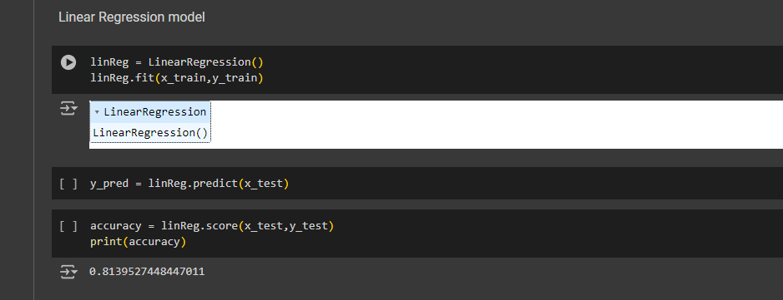

**Random Forest Model**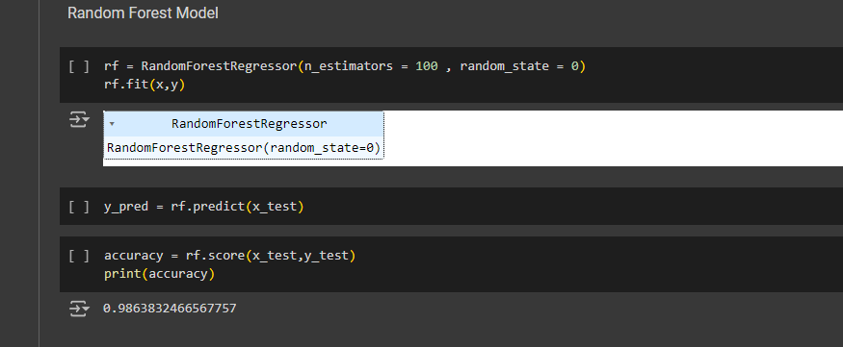

**XGBoost Regression Model**

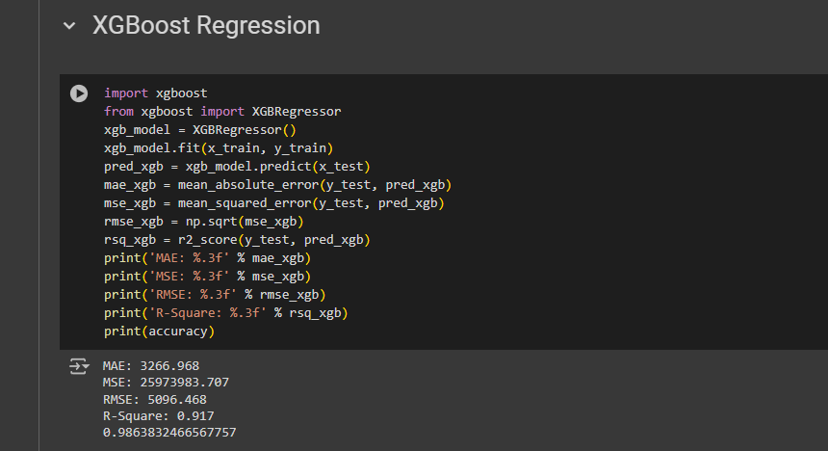

**Decision Tree Model**

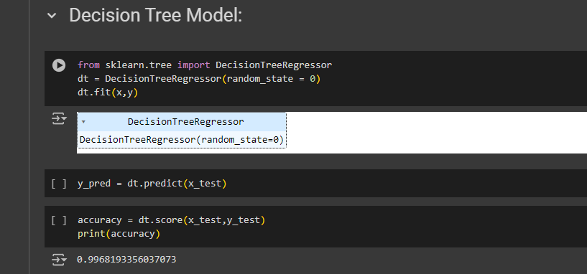

**Model Validation and Evaluation Report:**

|  |  |  |  |
| --- | --- | --- | --- |
| **Model** | **Regression Report** | **Accuracy** | **Regression Matrix** |
| Linear Regression |  | 81.3% |  |
| Random Forest Regressor |  | 98.6% |  |
| XGBoost Regression |  | 91.6% |  |
| Decision Tree |  | 99.6% |  |